**General information about light art**

**Introduction**

With the background information in this lesson you can prepare your group for Light Festival GLOW. Here you will find links to videos of light artworks, but also questions that stimulate discussions in the group. It is advisable to watch the videos before and to choose what you want to show.

**Eindhoven and light**

The Lichtjesroute of Eindhoven is crowded every year. There are probably some children who will also follow the route this year. A few weeks after the light route, GLOW light festival has been taking place in the city for years.

* *Why would there be two light activities in Eindhoven?*
* *What is the difference between the intention of the Lichtjesroute and that of the GLOW light festival?*
* *Do you also think the Lichtjesroute is light art? Why or not?*
* *What are the differences between making a Lichtjesroute ornament and a work of art for GLOW?*

[The Lichtjesroute](https://www.lichtjesroute.org/)  *September 18 to October 13, 2024*

The Lichtjesroute is only in Eindhoven. The reason for the existence of the route is the liberation of Eindhoven by the Allies on September 18, 1944. The soldiers were welcomed by the people of Eindhoven with lamps behind the windows.   
A fixed group of people work together on the well-known route. If you have visited the route before, you will recognize a number of light ornaments. Sometimes new ones are added.

Every year, more than 100,000 lights adorn the Lichtjesroute in Eindhoven. Eighty volunteers work for months to assemble all the lights of the 60 projects that are lit in our city of lights. Driving the Lichtjesroute yourself takes some time. That is why Omroep Brabant made a time- lapse video that allows you to experience the route in three and a half minutes. Buckle up, here we go……. [Film ( 3.39 min](https://www.youtube.com/watch?v=x6-5zQV5G60) .)

[GLOW](https://www.gloweindhoven.nl/nl)  *November 9 to November 16, 2024*

As with the Lichtjesroute, the organization and implementation of GLOW is a big job. Many people are involved.

At GLOW you can see light artworks by artists and designers from different countries, including the Netherlands. The organizers of GLOW determine a different theme every year, which makes GLOW a different 'exhibition' every year. This year's theme is 'The Stream'.

The works of art can be found in various places in the city. Some are specially made for a particular place; others already existed before, so a suitable place was found in Eindhoven.

* *Who has ever been to Glow?*
* *Who remembers a special light artwork from that?*
* *Does anyone know of a light artwork that really matched the place where it was displayed? Why did it fit so well there?*

Light festival GLOW has been around since 2006 and is always held in November. The artworks can only be seen every evening for a week, after which they disappear again. Some then travel to a (light) festival in another country, others go back to the makers. Very occasionally a work of art is bought by the city of Eindhoven. Then you can watch it more often. With this, Eindhoven wants to continue to inspire visitors to the city.

At the moment there are [10 light artworks](https://www.thisiseindhoven.com/nl/zien-en-doen/cultuur-en-design/10x-permanente-lichtkunstwerken-in-eindhoven) that you can see all year round in Eindhoven. For example, from October 2017, the artwork ' [Space](http://www.studioroosegaarde.net/project/space) ' by Daan Roosegaarde can be admired in the station passage. The globe here is peeled like an apple and forms a light wall of up to 90 meters long! The three centimeter thick wall consists of layers of processed satellite images printed on the back of lenses. Together with the LED lighting, it creates a kind of 3D hologram that moves with you when you walk past it. Give it a try! It is as if you are looking into an infinite depth .   
*Another worldwide famous light art project by Daan Roosegaarde in Eindhoven is the luminous* [*Van Gogh - Roosegaarde Cycle Path*](https://www.studioroosegaarde.net/project/van-gogh-path) *, hidden in the fields on the road to Nuenen. Maybe you've cycled over it in the dark?*

**Artists and works**

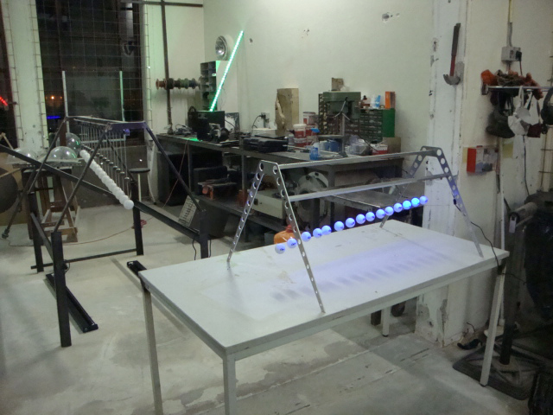A work of light art can be very extensive - some artists even create a kind of show: music or movement is added. To do this they work together with other artists, designers, musicians or technicians. And sometimes it's the other way around: someone with a technical profession gets a great idea and finds a form for it himself. That's the great thing about Glow: that everything is possible! Here are some examples.

*Ivo Schoofs* , ***Large Pendulum Wave*** (Glow 2013)

<http://youtu.be/tPviIj4KA2Q>(video 2:57)

Ivo Schoofs is an artist from Eindhoven who collaborates with other artists, technicians, scientists and designers. Watch on YouTube (video, 1:00) how he tries something: <http://youtu.be/6ft1-K5XkfY>

One group he works with is called *KineticHumor*. Various works can be seen on this site: <http://kinetichumor.nl/>

**Interactive light art**

Sometimes artists create works that 'react' to whoever looks at it, or when you touch it. In 2018, students from Fontys made a number of such interactive light installations: <https://www.youtube.com/watch?v=TaGhTGXor90>(video 2.02)

**Art made with light**

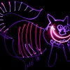Many artists are a bit of an inventor: they like to try new things and look for new or unusual materials. But it's not just about those materials for them. Material is a tool to show an idea, a thought or a feeling to others. The artist looks for the material that best fits that idea, feeling, or thought.

* *Do you think light is a material? Why yes/why not?*
* *What differences with other material can you think of?*
* *And which similarities?*

Making a work of art with light can be done in many ways, but the principle is simple: by turning the light on or off, you make a work of art appear or disappear!

With light you can:

* project images or films ('beam');

* create shadows;

* make shapes from large or small lamps;

* fill spaces or 'things' with light;

* and: you can even draw with light!

Watch how and what the American light artist Darren Pearson ('Darius Twin ') draws in the sky with (LED) flashlights:   
[Light Painting Photography — DARIUSTWIN - Light Painting Photography](https://www.dariustwin.com/light-painting-photography)

In the next video, Darren Pearson shows how he photographs the movements with his light in the sky to see the drawing. He explains in English. (video 2:00)

<http://www.youtube.com/watch?v=TeTzUzPfleU&feature=youtu.be>

**Light attracts attention**

Light catches the eye, so if you want attention, use light.

* *Who can name such a luminous attention grabber in Eindhoven? (also commercials!)*

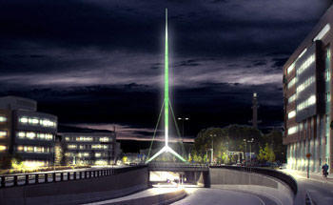

*(examples)*

*\** the 'Light Needle'

*

the viaduct at the High Tech Campus

One of the newest light artworks in Eindhoven is called 'De Zwerm' and can be seen in the tunnel under the Montgomerylaan. The artist's name is Frank Tjepkema . He made a design based on conversations with local residents.

[more about the artwork](https://www.eindhoven.nl/projecten/kruising-montgomerylaan-ring-hov2/lichtkunstwerk-zwerm)

[Photos _](https://www.ed.nl/eindhoven/bijzondere-blikvanger-op-kruising-in-eindhoven~af7114e8/155487767/)

* *Where would you create a light artwork that attracts attention?*
* *What would that look like?*